Main System Screen: 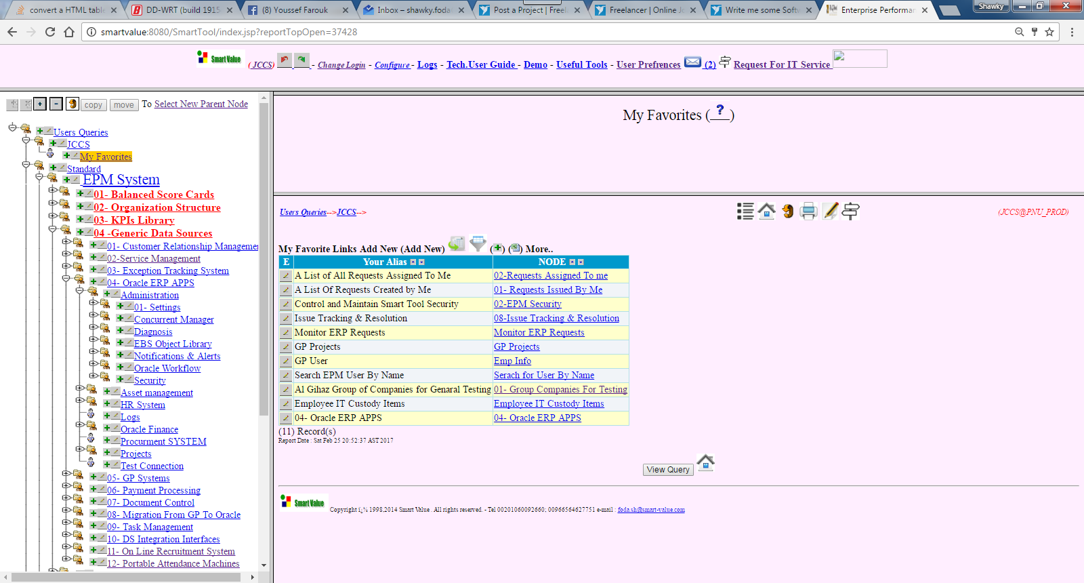
Sample Multi Section Screen (Readonly) :
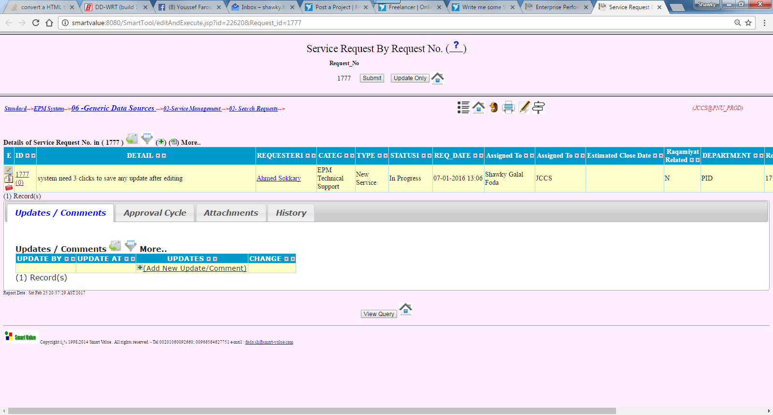

Sample Multi Section Screen ( With Editing ability ) :
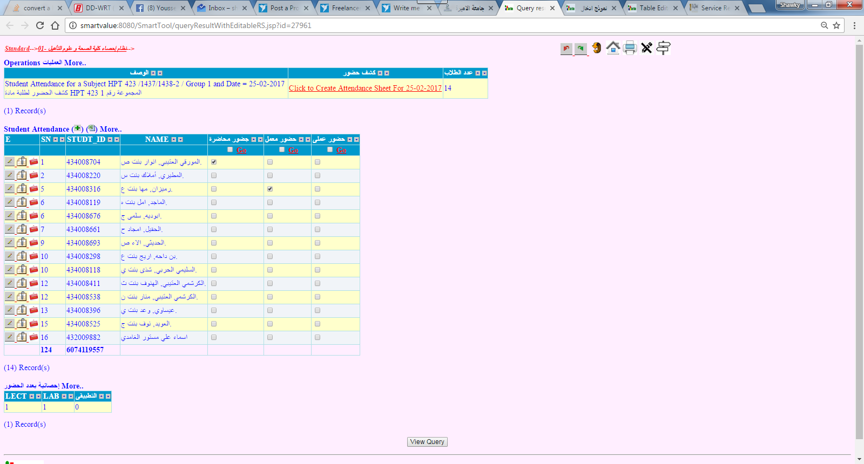
Sample Object Editor Screen :
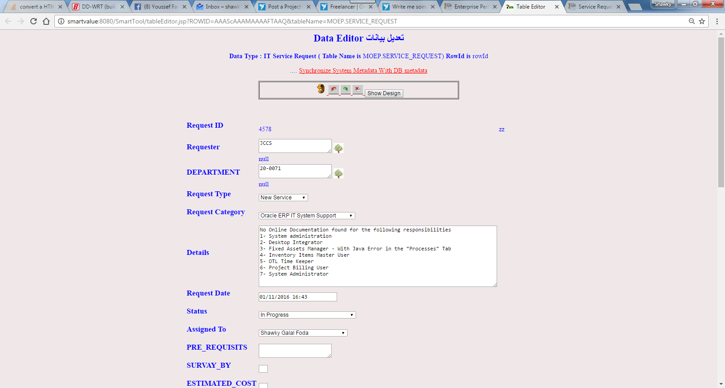

Sample Object Creation Screen:
